Install Microsoft visual objective Tagging tool(VOTT):

Step 1:

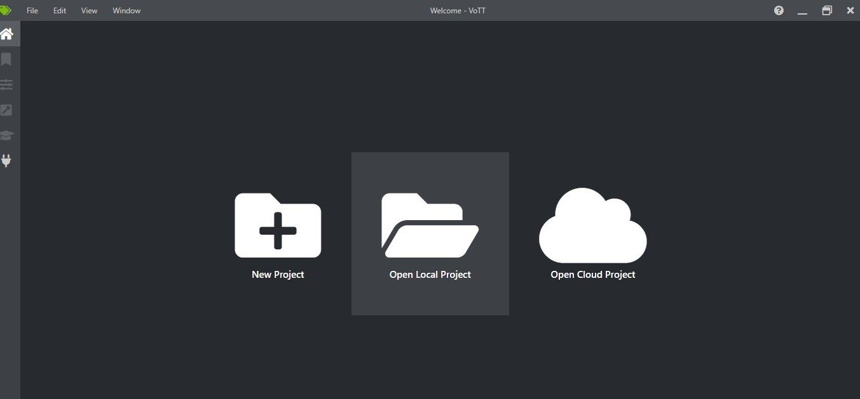

Step 2:

